A000-Asia-China-Hongshan-Disc-4 Notches-Hsuan chi-3500-2200 BCE

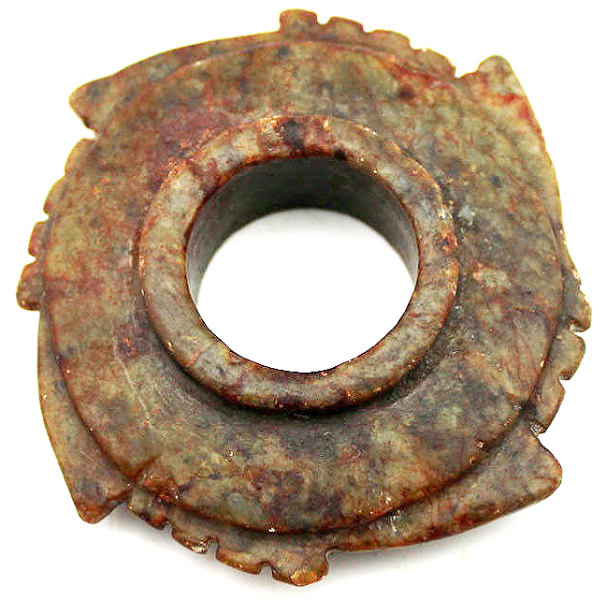

**Case No.: 5**

**Accession No.**

**Formal Label:**

**Display Description:**

**Accession Number:**

**LC Classification:**

**Date or Time Horizon:**

**Geographical Area:**

**Map:**

**GPS coordinates:**

**Cultural Affiliation:**

**Media:**

**Dimensions:**

**Weight:**

**Condition:**

**Provenance:**

**Discussion:**

**References:**

